Project Overview

PROJECT OVERVIEW

1. Introduction
ThermoVerse Inc. is an urban energy storage startup headquartered in Detroit, Michigan. The company is pioneering the world’s most compact, zero-footprint thermal battery to unlock essential grid capacity in densely populated cities where strict fire codes preclude the use of traditional Battery Energy Storage Systems (BESS).

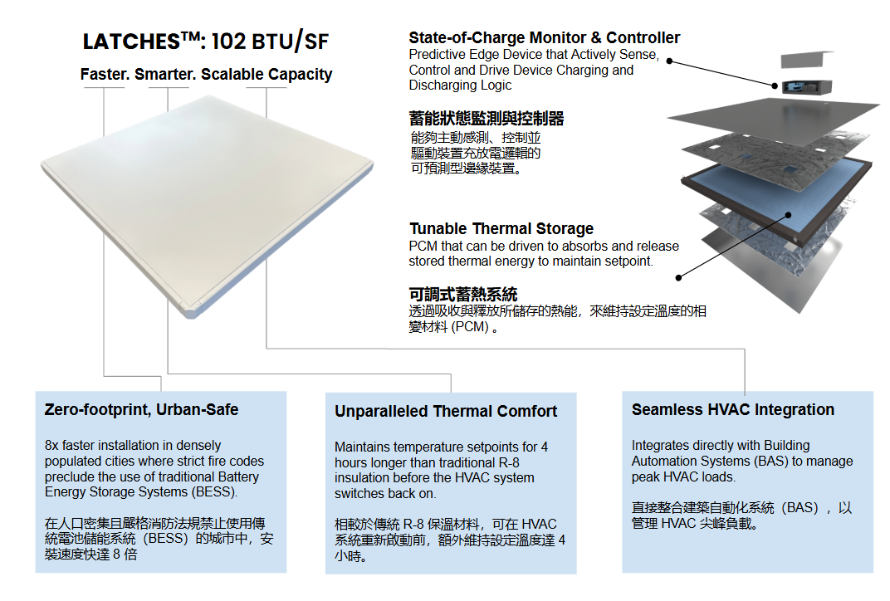

Following participation in the IC Taiwan Grand Challenge Showcase in June 2026, and a month-long business trip to Taipei spanning August 1 - 23 and August 30 - Sept 10, ThermoVerse Inc. will be participating in FUTEX 2026. The Expo will take place between Sept 17 - 19 at Taipei World Trade Center. The company’s primary objectives at FUTEX 2026 are:

- Supply Chain Management - relating to the development of customer Predictive Edge Devices/ Controllers to command the time release of stored thermal energy in LATCHESTM (Large-Area Transactive Cooling & Heat Energy Storage), a zero-footprint thermal battery that reduces peak HVAC (Heating, Ventilation & Air Conditioning) energy by 20-60%.
- Demand Management - relating to securing Proof-of-Concept (POC) projects or pilot demonstration in dense urban environments where traditional chemical batteries are either banned or restricted.

Milestone/ History (in Taiwan):
A brief history of our involvement in Taiwan is provided below.

Timeline | Milestone Name | Description
June 2026 | 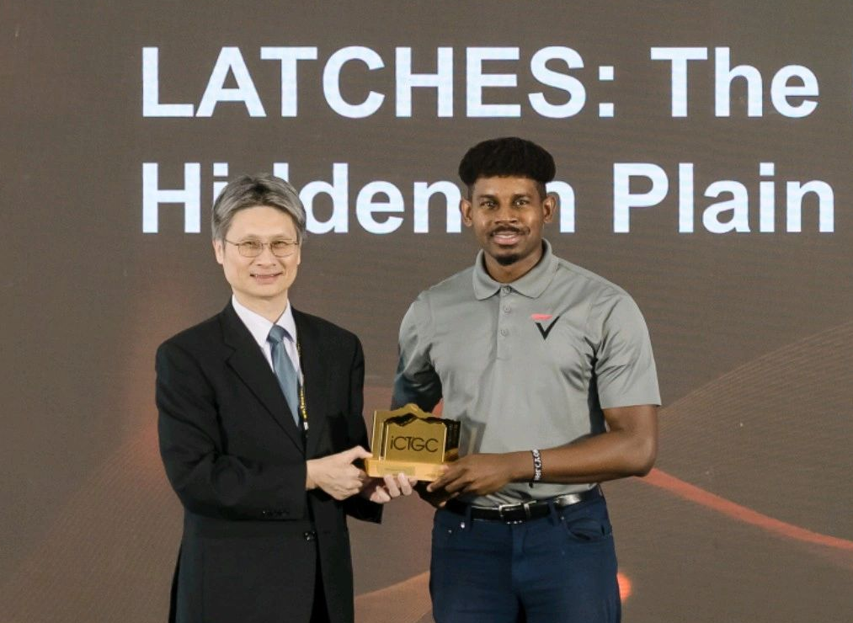  Supporting Doc: Link | The company made its debut in Taiwan upon winning the 2026 ICTGC Winner (Sustainability), where they sought supply chain partnerships to transition and expand the production of their existing edge device from China to Taiwan.
July 2026 | 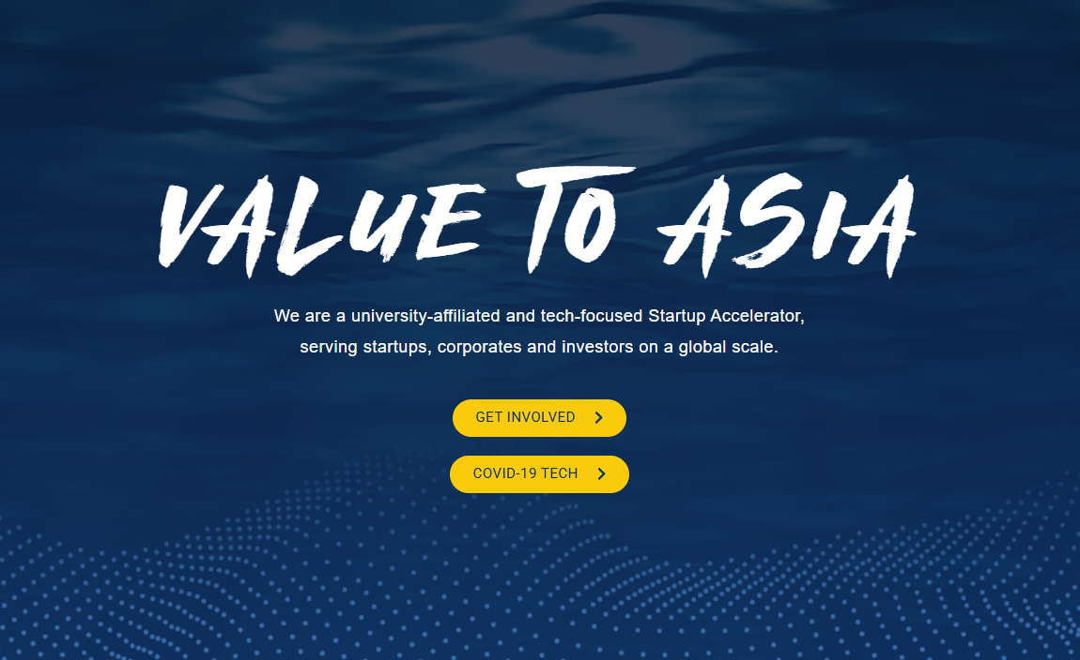  Supporting Doc: Link | The company was invited to join the IAPS Accelerator by the National Yang Ming Chiao Tung University (Center of Industry Accelerator and Patent Strategy, National Chiao Tung University) to work with local Taiwanese partners to develop a custom predictive edge device to command the time release of stored thermal energy in LATCHES.
August 2026 | 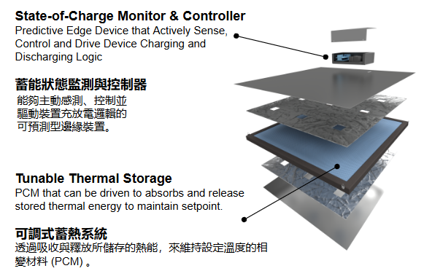  Supporting Doc: Link | In advancing Objective 1 (above) the company has partnered with LMT ( Light Momentum Technology Corp.) through a local university-run accelerator known as IAPS. This collaboration entails developing a fully-integrated system-on-chip State-of-Charge Monitoring (SoCM) device to act as the central intelligence for LATCHESTM - the world’s most compact dispatchable thermal battery.
September 2026 | 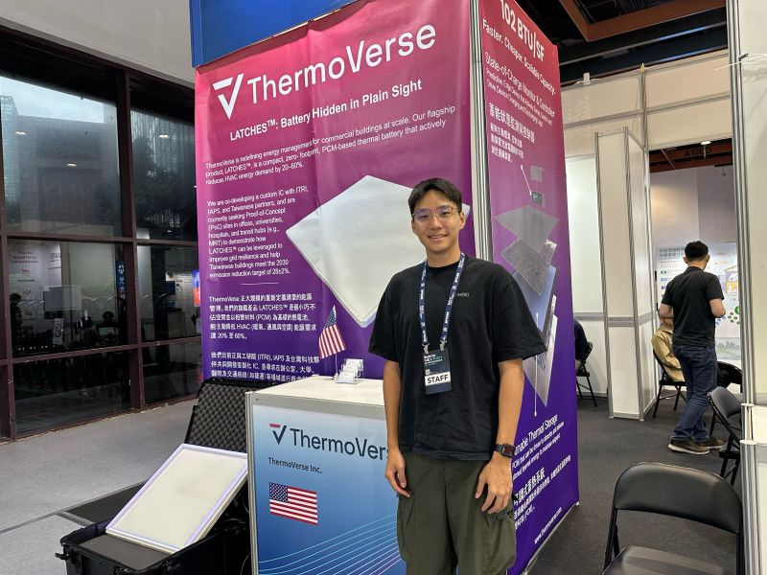  Supporting Doc: Link | In advancing Objective 2 (above) the company has attended the Build for NextGen Expo, where it showcased LATCHES as a zero-footprint, urban-safe solution to help Taiwan and the Taiwan Intelligent Building Association (TIBA) reduce peak HVAC building load while complying with Net-Zero targets. Separately, the company is also exploring relationships with the Taipei Computer Association (TCA) to formalize a local subsidiary and to expand our footprint to Taipei.

Current Work: We seek a Contractor to act as a local marketing representative for ThermoVerse Inc. in Taipei, Taiwan. This includes on-site representation at FUTEX (September 17–19, 2026, at TWTC Hall 1), physical logistics for company demonstration materials, targeted academic matchmaking for US-Taiwan R&D grant co-proposals (e.g., MOEA A+, Taiwan SBIR, etc.), and a bilingual optimization of the Company's website and CRM system.

Statement of Work

INDEPENDENT CONTRACTOR STATEMENT OF WORK

This Statement of work is entered into by and between ThermoVerse Inc. and an Independent Contractor or Independent Marketing Coordinator (hereinafter referred to as “Contractor” or “The Contractor). The Contractor will act as a local marketing representative for ThermoVerse Inc. (the "Company") in Taipei, Taiwan. The Services include a one-time bilingual optimization of the Company’s website, setup of a basic CRM lead-management workflow, documented academic outreach, FUTEX representation, and demo logistics within the scope stated in this SOW. Academic outreach will be evaluated based on the documented actions and deliverables completed by the Contractor, while third-party responses, partnerships, grant eligibility, grant approval, and funding remain external outcomes.

2. Team Roles and Responsibilities
To ensure seamless execution during the event and project lifecycle, the following table outlines the primary stakeholders and their respective responsibilities:

Name | Role / Title | Key Responsibilities
Shantonio Birch | President | Facilitate contractor hiring, oversee overarching logistics, and manage post-event information retrieval and strategic follow-up.
Mani Sainadh Venkata Sathi Reddy | Manufacturing Engineer & SCM | Coordinate and manage supplier relationships with industry partners generated from the expo.
Paixun Lin | Control Engineer | Act as the primary point of contact (paixun@thermoverse.com) to assist the Contractor in the initial daily setup and troubleshooting of the LATCHES demo unit (9:00 AM – 11:00 AM local time).
Contractor | Independent Marketing Coordinator | Act as the on-site company representative and uphold ThermoVerse Inc.'s core values: FAITHE (Foundational Excellence, Agency, Intentional Collaboration, Transparency, Horizon, Relational Equity). Responsible for the pickup, transport, and drop-off of the demo unit, executing the 3-day expo representation, conducting targeted academic outreach, and completing the permanent bilingual website optimization.

Company Dependencies: The Company will provide the final product wording and guidelines once this SOW is complete and mutually agreed upon. Furthermore, ThermoVerse Inc. shall provide all required brand assets, approved technical information, website access, account access, privacy-policy content, demo instructions, venue credentials, and consolidated approvals according to the agreed schedule. The Company is responsible for the accuracy and substantiation of all technical, regulatory, product-performance, grant-related, and marketing claims supplied or approved by the Company.

3. Services and Deliverables

A. Logistics & Equipment Handling
- Pickup & Inventory: Retrieve the demo container housing the LATCHES from on or before September 9, 2026, by 17:00 (Taiwan Local Time). Before pickup, the Company shall provide an equipment inventory, photographs, declared replacement value, dimensions, weight, handling instructions, operating instructions, and disclosure of any special transportation requirements.
- Condition Check: The parties shall document the condition of the demo container at pickup and return to ensure a clear and efficient handover.
- Transport & Drop-off: Safely transport the demo container to TWTC Hall 1. Upon conclusion, securely pack and drop off the container to Dr. Hou at the ITRI Nangang Software Park on September 21, 2026, coordinating with Sanna Wei (sannawei@itri.org.tw). Additional arrangements shall be made if the container cannot be stored at the ITRI location in the Nangang Software Park.
- Liability: The Contractor will be responsible for loss or damage caused by the Contractor’s willful misconduct or gross negligence. Inherent defects, normal wear and tear, inadequate packaging, and undisclosed hazards will remain the Company’s responsibility.

B. Expo Representation (3 Days)
- Event: Attend and represent ThermoVerse Inc. at FUTEX (TWTC Hall 1, Taipei).
- Dates & Hours: September 17–19, 2026. The day rate covers attendance from 9:00 AM to 5:30 PM Taiwan Time, including reasonable meal and rest breaks. Work requested outside these hours, separate setup or teardown work, or additional event days requires prior written approval and a mutually agreed additional fee.
- Daily Setup & Sync: The Contractor is expected to arrive at 9:00 AM for booth setup. The ThermoVerse Inc. US team will be available between 9:00 AM and 11:00 AM (Taiwan Local Time) to facilitate setup.
- Duties & Company Provisions: Manage the booth, utilize the LATCHES demo, and capture leads. The Company shall provide or pay for required exhibitor credentials, booth access, electricity, internet access, and display equipment.

C. Targeted Academic Matchmaking & Outreach
- Scope & Evaluation: The Contractor will make documented outreach efforts to the initial three academic contacts (NYCU, NTUST, and NTU) identified by the Company, as well as any additional relevant organizations introduced on the floor during the matchmaking event (removing the strict restriction to only three targets). Completion will be measured by sending Company-approved messages, making reasonable on-site contact attempts where feasible, and delivering a written activity and response summary. Recipient responses, meetings, partnerships, grant qualification, and funding will be treated as follow-up opportunities rather than required deliverables.
- On-Site Execution & Talking Points: When visiting the booths, utilize the following structured talking points to qualify the initial partners:
  - NYCU Booth (Dr. Sheng-Yu Peng):
      - "Is your embedded analog flash IP strictly monolithic, or do you have experience exporting it as a Known Good Die (KGD) for heterogeneous integration (SiP)?"
      - "Can your event-driven front end be tuned to capture ultra-low-frequency, microvolt-level analog signals (like thermal state changes) amidst digital switching noise?"
      - "We are currently structuring a US-Taiwan R&D grant proposal (e.g., MOEA A+, Taiwan SBIR, or Taipei City grants). Does your lab collaborate with private edge-hardware startups on custom mixed-signal integration?"
  - NTUST Booth (Dr. Ping-Chun Tsai):
      - "Your platform targets next-gen battery tech—can the multiscale models be applied to physical Phase Change Materials (PCMs) or solid-state thermal interface materials undergoing rapid thermal cycling?"
      - "Can your software simulate thermomechanical stress at the SiP (System-in-Package) substrate level to predict material fatigue before we pay an OSAT for physical prototyping?"
      - "How does NTUST usually structure joint research for government funding matches (e.g., MOEA A+, Taiwan SBIR, or local Taipei subsidies)?"
  - NTU Booth (Dr. Ya-Yu Chiang):
      - "Your 312.2 W/cm² metric is incredible. How scalable is the form factor of the helical structure? Can it be miniaturized to cool localized TEC heat sinks, or is it strictly for large pool boiling?"
      - "Since this is a passive system (zero parasitic energy), we see a massive application in data centers and building automation (BMS). Have you explored demand-aggregation or smart-facility deployment?"
      - "Furthermore, we are actively structuring a US-Taiwan R&D grant proposal (e.g., MOEA A+ or Taiwan SBIR, etc.) and are evaluating academic partnerships."
- Approvals: All recipient information, technical claims, grant references, talking points, and final outreach messages must be approved in writing by the Company before use.

D. Website Optimization & CRM Integration
- Schedule & Delivery: All dates and deadlines under this SOW are based on Taiwan Time (UTC+8). The Contractor will provide the first review version on September 11, 2026, the second review version on September 13, 2026, and the final deliverable on September 15, 2026.
- Website Scope: Limited to five page types—Home, Technology, Use Cases, About Us including FACES, and Contact Us—in Traditional Chinese and English, for a total of ten localized pages. The fee includes responsive desktop and mobile layouts, basic page titles and meta descriptions, correction of identified broken navigation links, deployment, and a basic handover guide.
- Content Architecture & Value Proposition:
  - Home & Technology: The core focus must emphasize urban-safe energy storage tied directly to HVAC systems. The pages must explicitly highlight a Zero-footprint, Urban-Safe Installation and address the critical need for alternatives to chemical BESS. Highlight the State-of-Charge Monitor & Controller and Tunable Thermal Storage, emphasizing Unparalleled Thermal Comfort and Seamless Integration (BacNET-native). Note: Before publication, the Contractor and the Company will review and confirm all technical terminology, product-performance figures, safety statements, code-compliance statements, energy-saving claims, and carbon-credit wording. Such content may be published only after the Company provides written approval.
  - Use Cases: The page will invite stakeholders to apply as potential POC site partners using the CTA: "Apply as a POC Site Partner". Submission of an inquiry does not create a POC agreement; POC scope, equipment, and responsibilities will be agreed separately in writing.
  - About Us: Include company positioning, the founding story, and introduce FACES.
- CRM Scope: Includes a lead list, lead-detail records, inquiry type, source page, website language, submission time, follow-up status, notes, search, filtering, CSV export, and notification to a Company-designated email address. The Company will own and administer the production account and submitted lead data. (Advanced automation, historical-data migration, and ongoing CRM administration are excluded).

4. Review and Acceptance

The fee includes a maximum of three consolidated revision rounds. Each round begins when the Company submits one consolidated written feedback list and ends when the Contractor delivers the corresponding revised version. Delayed Company feedback will extend the following deadline by the corresponding delay. Material defects that cause the deliverable not to conform to the agreed scope will be corrected without counting as a revision round. New content, changed preferences, out-of-scope requests, and revisions beyond the three included rounds require a written change order.

5. Additional Legal Terms
- Intellectual Property: Upon full payment, the Company will own the final website copy, page layouts, and project-specific CRM configuration created exclusively under this SOW. The Contractor retains ownership of pre-existing tools, templates, methods, and reusable components, granting the Company a perpetual license to use components embedded in the final deliverables.
- Confidentiality & Personal Data: Each party will protect non-public information. The Company is responsible for approving the privacy notice, lawful collection purpose, and marketing-consent language.
- Cancellation & Termination: Either party may terminate for material breach if not cured within five business days after written notice. If FUTEX is cancelled or materially disrupted for reasons outside the Contractor’s control, the Company will pay for completed work, non-cancellable commitments, and approved expenses incurred.
- Limitation of Responsibility: Third-party platform outages, venue decisions, recipient responses, grant outcomes, product defects, and Company-supplied claims will remain outside the Contractor’s responsibility. Except for willful misconduct, gross negligence, breach of confidentiality, or misuse of personal data, each party’s aggregate liability arising from this SOW will not exceed the total fees paid or payable under this SOW.
- Governing Law and Jurisdiction: This SOW shall be governed by the laws of Taiwan (Republic of China), without regard to conflict-of-law principles. The Taiwan Taipei District Court shall have exclusive jurisdiction as the court of first instance over any dispute.

6. Payment Schedule & Terms Compensation is based on the deliverables and exclusions stated in this SOW. Requests outside the stated scope require a written change order specifying the additional fee and schedule before work begins.
- Expo Day Rate: $175 USD per day for 3 days of expo attendance. (Total: $525 USD).
- Website Updates & CRM Setup: A flat project fee of $675 USD for the bilingual website optimization, basic CRM, and documented academic outreach.
- Total Base Compensation: $1,200 USD.
Invoicing & Reimbursement
- Expenses: The Company will reimburse reasonable and necessary expenses approved in writing before they are incurred (e.g., demo transportation, courier charges, event-related local transit/parking). Valid digital receipts must be submitted with the applicable invoice.
- Invoicing: The Contractor may invoice $675 upon delivery and acceptance of the website/CRM/outreach, and $525 upon completion of the three FUTEX days.
- Payment Terms: Each undisputed invoice is payable within 30 calendar days of receipt (Net 30). The Company must identify disputed items in writing within five business days. The Company will bear outgoing and intermediary wire-transfer fees.

SIGNATURES

By signing below, both parties agree to the scope, terms, and payment schedule outlined in this Statement of Work.

For ThermoVerse Inc.
Signature: _________________________________________
Name: Shantonio Birch
Title: President
Date: ________________________

For the Contractor
Signature: _________________________________________
Name: Pin Zhi Ye
Title: Independent Marketing Coordinator
Date: ________________________

APPENDIX A: OUTREACH EMAIL TEMPLATES

Before any email is sent, the Contractor and the Company will review and confirm the recipient information, technical statements, grant references, timing references, and final email content. Emails may be sent only after the Company provides written approval of the final version.

Email 1: To Dr. Sheng-Yu Peng (NYCU)
- To: speng@nycu.edu.tw
- CC: birch@thermoverse.com, mani@thermoverse.com
- Subject: FUTEX 2026: ThermoVerse Inc. & NYCU SiP/Analog Edge Integration (US-Taiwan R&D Grants)
- Body:
Dear Dr. Peng,
My team from ThermoVerse Inc. will be attending FUTEX next week, and we are highly interested in your embedded analog flash RNN architecture.
ThermoVerse Inc. is currently developing edge controllers for thermal energy storage latches. To reduce the latency and power consumption of microvolt-level Seebeck measurement, we are transitioning to a System-in-Package (SiP) architecture and exploring event-driven analog front ends to bypass traditional ADCs.
We are currently evaluating academic partners for an upcoming US-Taiwan R&D grant co-proposal (e.g., MOEA A+, Taiwan SBIR, or Taipei City grants). We would love to stop by your booth to discuss whether your IP can be leveraged as a Known Good Die (KGD) for our SiP roadmap. Please let us know if there is a preferred day or time to connect at TWTC.
Best regards,
[Contractor Name / ThermoVerse Inc. Team]

Email 2: To Dr. Ping-Chun Tsai (NTUST)
- To: pctsai@mail.ntust.edu.tw
- CC: birch@thermoverse.com, mani@thermoverse.com
- Subject: FUTEX 2026: ThermoVerse Inc. & NTUST Predictive Materials Modeling (US-Taiwan R&D Grants)
- Body:
Dear Dr. Tsai,
Our team at ThermoVerse Inc. is looking forward to seeing your Autonomous Materials Intelligence Platform at FUTEX next week.
We design advanced thermal energy storage latches and controllers. A critical bottleneck in our R&D is the physical trial-and-error testing of Phase Change Materials (PCMs) and the thermomechanical stress on our semiconductor (SiP) substrates during rapid thermal cycling. Your computational approach to predicting interface behavior and fatigue aligns perfectly with our roadmap to lower our upfront NRE and embodied carbon.
We are currently structuring a US-Taiwan R&D grant proposal (e.g., MOEA A+, Taiwan SBIR) and are looking for strong academic R&D partners. We plan to visit your booth to discuss if your multiscale models can be applied to solid-state thermal interface materials. Let us know when you might be available for a brief conversation!
Best regards,
[Contractor Name / ThermoVerse Inc. Team]

Email 3: To Dr. Ya-Yu Chiang (NTU)
- To: yayuc@ntu.edu.tw
- CC: birch@thermoverse.com, mani@thermoverse.com
- Subject: FUTEX 2026: ThermoVerse Inc. & NTU Passive Helical Cooling Applications (US-Taiwan R&D Grants)
- Body:
Dear Dr. Chiang,
The ThermoVerse Inc. team will be walking the FUTEX floor next week, and your passive helical vapor-liquid separation technology caught our immediate attention.
We build thermal battery latches and advanced controllers for smart buildings and data centers. Managing extreme heat fluxes from Thermoelectric Coolers (TECs) without adding parasitic energy draw (like fans or pumps) is central to our hardware strategy. Achieving 312 W/cm² entirely passively is a remarkable breakthrough.
We would love to visit your booth to discuss the form-factor scalability of your design, and whether it can be adapted to localized TEC heat sinks. Furthermore, we are actively structuring a US-Taiwan R&D grant proposal (e.g., MOEA A+, Taiwan SBIR, Taipei City R&D Subsidies) and are evaluating academic partnerships.
Please let us know what day works best for a brief introduction at your booth.
Best regards,
[Contractor Name / ThermoVerse Inc. Team]

Website Guidelines

ThermoVerse Website Content Blueprint (for Services + Tech)

📄 Page 1: Home
- Purpose: Explain what the company does, who it serves, and what to do next. Note for developer: This page must balance our immediate Energy Services revenue engine with our LATCHES technology innovation.
- PROPOSED MESSAGE: Reduce building energy use through expert energy services, and future-proof your assets with our advanced thermal battery innovation.
- PRIMARY CTA: Discuss a Project
- SECONDARY CTA: Explore LATCHES Technology

Page Sections

01 Hero: Expert Energy Services & Thermal Innovation
  - Headline: Optimizing Building Performance Today. Pioneering Thermal Storage for Tomorrow.
  - Sub-headline: ThermoVerse delivers comprehensive energy services and assessments to slash your building's operational costs immediately. We are also the developers of LATCHES: the world’s first BACnet-native, zero-footprint solid-state thermal battery.
02 Peak Demand, Comfort, and Energy Challenges
  - Copy Guidance: Detail the immediate pain points facility managers face: rising utility tariffs, failing HVAC equipment, strict ESG mandates, and the difficulty of navigating energy audits and retrofits.

03 Core Solutions: Energy Services & LATCHES Summary
  - Copy Guidance: Split this section into two distinct pillars:
    - Energy Services: Highlight BPI energy assessments, ASHRAE audits, MEP consulting, and immediate energy retrofits.
    - LATCHES Innovation: Introduce our proprietary thermal battery (102 BTU/SF capacity, BACnet-native control, and zero-footprint installation).

04 Commercial, Industrial, and Multifamily Applications
  - Copy Guidance: Detail how we deploy our services and upcoming thermal batteries across these three asset classes to reduce Energy Use Intensity (EUI).
05 How Measured Reductions Support ESG Reporting
  - Copy Guidance: Explain how our energy audits and future LATCHES load-shifting generate verified data to support institutional ESG reporting, local compliance, and tax incentives.

06 Partners and Awards
  - Copy Guidance: Showcase industry certifications (e.g., BPI), academic research ties, and innovation awards to build trust.

📄 Page 2: Technology (LATCHES)

Headline: Turn Your Ceiling Into a Programmable Thermal Battery.

Sub-headline: ThermoVerse introduces LATCHES: The world’s first BACnet-native, zero-footprint solid-state thermal battery that can be commanded for the timed release of stored thermal energy in PCMs. Bypass strict fire codes, slash peak HVAC loads, and meet your building's ESG targets—without forfeiting rentable floor area.

- Purpose: Explain how our proprietary LATCHES thermal battery works and outline assessment needs for future adoption.
- PRIMARY CTA: Discuss Your Requirements

Page Sections

01 LATCHES Thermal Battery Overview
  - Copy Guidance: Position LATCHES as a zero-footprint, solid-state thermal battery designed to bypass urban fire codes and save rentable floor area.

02 Phase-Change Materials and PCM Thermal Storage
  - Copy Guidance: Detail the PCM storage medium (102 BTU/SF capacity) that maintains temperature setpoints 4 hours longer than standard insulation.

03 The Sensing, Storage, and Control Process
  - Copy Guidance: Explain the predictive edge controller and how it commands charge/discharge cycles for the timed release of stored thermal energy.

04 Integration Within Ceilings and Walls
  - Copy Guidance: Visualize the zero-footprint drop-ceiling integration and 8x faster installation.

05 Heat-Flow Control, Peak Management, and Demand Response
  - Copy Guidance: Emphasize the BACnet-native integration to manage peak demand via the building's existing BAS.

06 FAQ: Suitability, Integration Needs, and Assessment Data
  - Copy Guidance: Address network compatibility, ceiling weight, and the building data we gather during our Energy Services audits to qualify a site for LATCHES.

📄 Page 3: Use Cases & Services
- Purpose: Highlight our service capabilities across asset classes and recruit Proof-of-Concept (POC) site partners for LATCHES.
- PRIMARY CTA: Schedule an Energy Assessment / Apply for POC

Application Matrix

Application PDF | Building Challenge PDF | ThermoVerse Value (Services & LATCHES) PDF | Assessment Inputs Needed PDF
Commercial | High utility tariffs and strict urban fire codes. | Immediate energy audits + Future active thermal load-shifting via LATCHES. | Operating hours, utility tariff data, HVAC loads.
Industrial | Thermal bridging causing EUI spikes and equipment wear. | MEP assessments to optimize process heat + localized thermal buffering via LATCHES. | Thermal loads, equipment specs, site conditions.
Multifamily | Tenant thermal discomfort and high common-area HVAC costs. | Comprehensive BPI energy assessments + zero-footprint ceiling thermal regulation. | Floor plans, HVAC layout, occupancy data.

📄 Page 4: About Us
- Purpose: Show prospective partners the company's origins, service expertise, and innovation direction.
- PRIMARY CTA: Connect with Our Team

Page Sections

01 Company Positioning and Mission
  - Copy Guidance: We bridge the gap between today's energy service needs and tomorrow's thermal storage innovations.

02 Founding Story and Founder Introduction
  - Copy Guidance: Share the origins of our energy service expertise and the engineering breakthrough behind LATCHES.

03 Research and Deployment Milestones
  - Copy Guidance: Timeline showing active energy service projects and LATCHES development milestones.

04 Approved Team Profiles and Partners
  - Copy Guidance: Highlight certified energy auditors, engineering team, and research ties.

05 Company Values and the FACES Program
  - Copy Guidance: Introduce our workforce program training energy trades and engineering professionals.

06 Location and Contact Details

📄 Page 5: Contact Us
- Purpose: Capture context to identify if the lead needs immediate energy services or wants to partner on LATCHES technology.
- PRIMARY CTA: Submit Inquiry

Form Structure & CRM Fields
- Required Fields: Name, Email, Inquiry Type, Message.
- Inquiry Type Options (Crucial for CRM Routing):
  - Schedule an Energy Assessment (Services) (New)
  - Apply for LATCHES POC Site Partnership
  - Technology / Engineering Inquiry
  - FACES Workforce Program Interest
  - General Inquiry

- Data Usage: Unchecked optional marketing opt-in.

